Judicial Elections Project

**Capsules:**

**Explainer/Panels:**

Hed:Politicians in Black Robes

Dek: N/A

Intro: Spending on state judicial elections, especially independent, hard-to-track spending has exploded over the last decade. Judges and fair courts advocates say that’s a bad thing.

Panel 1: Most people probably don’t even think about judicial elections, but judges in 38 states will face voters at some point in their time on the bench, whether in the initial election or through retention elections.

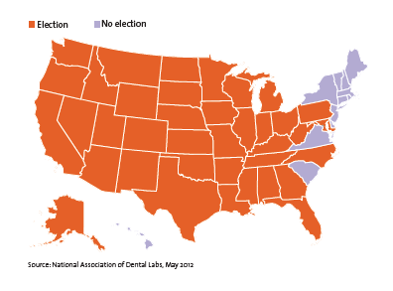

Panel 2: But good data about how independent spending on judicial races is hard to get. A recent analysis by the National Institute on Money in State Politics gave 26 states a failing grade for independent spending disclosure requirements. The grade is based on how strictly a state requires reporting of independent expenditures, electioneering ads and the target of the spender.

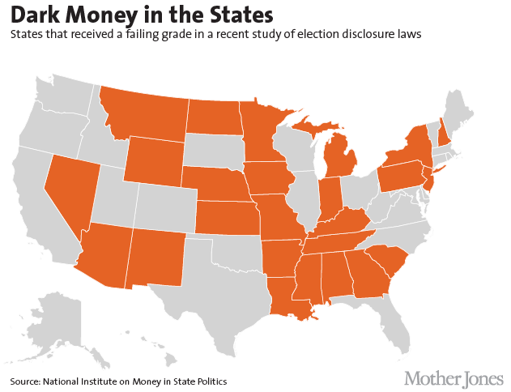

Panel 3: In some places lax disclosure laws overlap with incredible spending on judicial examples. Alabama has seen by far the vast majority of contributions to judicial candidates since 2000 ($48 million compared to the second-place state, Ohio, which saw $27.6 million). In these places it's nearly impossible to know how much money was actually spent.

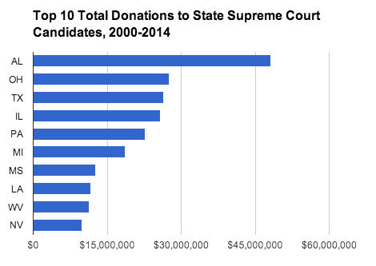

Panel 4: This wasn't a major problem until the late 80s when a guy named Karl Rove started targeting judicial races in Texas. In the 1990s it really took off, with the total fundraising jumping to more than $206 million in the 2000s from $86 million in the 90s.

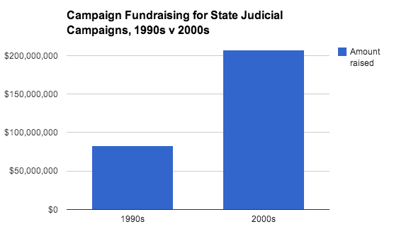

Panel 5: As the money continues to increase, larger portions are being spent independent of specific candidates or campaigns. “We ask courts to be fair and impartial, not political," says Bert Brandenberg, executive director of Justice at Stake. "[Chasing campaign dollars and the infusion of independent spending] tears away at the insulation around the courts, turning them into politicians in black robes."

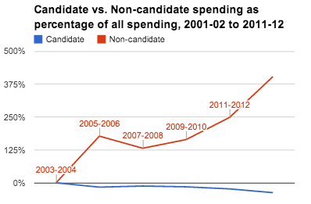

Panel 6: The battle lines are fairly clear: “Court wars are tort wars,” says Alicia Bannon of the Brennan Center for Justice. The battle generally pits big business and Republicans against trial lawyers and Democrats. Both sides have poured tens of millions(TOTALS TK) into the fight over the last decade.

*(*need to figure out how to illustrate this. Thought we needed more context.*)*

Panel 7: This is a bigger deal in some states. The top 10 states over the last decade, in terms of state judicial campaign contributions and estimated outside spending, account for nearly $200 million dollars.

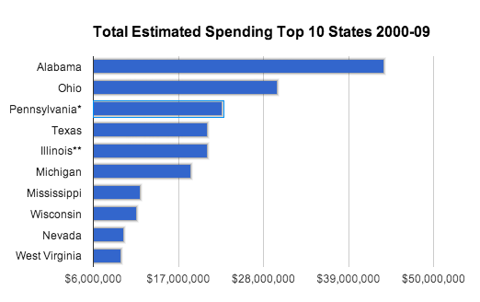

Panel 8: A relative few super spenders are dominating the independent spending game. Groups like the US Chamber of Commerce, the Republican and Democratic parties in Michigan and others have spent tens of millions on state judicial races since 2000. More recently, the Republican State Leadership Committee has been spending a lot of money in places like North Carolina.

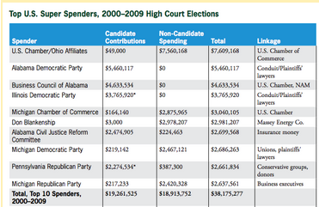

*(**this will probably be a top-5 table or something…**)*

Panel 8: A lot of this independent spending goes toward TV ads, which get nastier with more independent spending.



Panel 9: Spending on these types of ads has exploded over the last few years, reaching nearly $34 million in the 2011-12 cycle.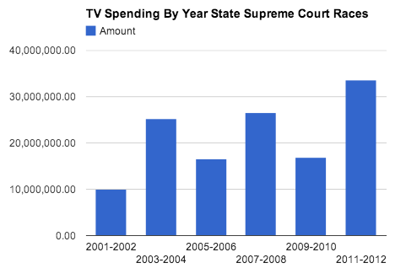

Panel 10: A prominent critic of the money in state judicial elections says even the perception of bias undermines the whole system. “Judicial elections pose a serious threat to judicial independence, and to the public’s perception of that independence,” says retired US Supreme Court Justice Sandra Day O’Connor. “If judicial decisions are in fact not fair and impartial – or even if they are perceived as being biased – the basis of support for our courts crumbles.”

